**Course Syllabus
Topics to be Covered in Theory Class

List of Topics | No. of  Weeks | Contact Hours
Introduction, Background and Overview of the course  Error Detection and Correction  Types of Errors ,Error Detection, Error Correction, Cyclic Codes  Cyclic Redundancy Check, Checksum | 3 | 6
Network Layer: Logical Addressing  IPv4 ADDRESSES, Address Space , Notations , Classful Addressing  Classless Addressing, Network Address Translation (NAT) ,  IPv6 ADDRESSE, IPV6 Structure | 7 | 4
Network Layer: Internet Protocol  INTERNETWORKING, IPv4, IPv6, TRANSITION FROM IPv4 TO IPv6, Dual Stack , Tunneling, Header Translation | 2 | 4
Quality of Service (QoS)  Flow characteristics, Flow Classes, Techniques to Improve QoS  Integrated Services, Differentiated Services | 2 | 4
Network Management: SNMP  SIMPLE NETWORK MANAGEMENT PROTOCOL (SNMP)  Concept , Management Components Structure of Management Information, Management Information Base (MIB) , SNMP  Messages , UDP Ports, Security | 3 | 6
Cryptography  SYMMETRIC-KEY CRYPTOGRAPHY ,Traditional Ciphers  Simple Modem Ciphers ,Modem Round Ciphers, Mode of Operation , ASYMMETRIC-KEY CRYPTOGRAPHY, RSA | 2 | 4
Security in the Internet: IPSec, SSL/TLS, PGP VPN, and Firewalls  IPSecurity (IPSec) ,Two Modes ,Two Security Protocols | 1 | 2
Revision & Discussion | 1 | 2
- Course Description (As per course Specification)
This course introduces the state of the art advance topics in network protocol, architecture and applications. Important topics cover include Data Link Layer: Error Detection and Correction, Network Layer: Logical Addressing, Delivery, Forwarding, and Routing, Quality of Service (QoS), Network Management: SNMP, Cryptography, Security in the Internet: IPSec, SSL/TLS, PGP VPN, and Firewalls.

- Course Learning Outcomes (As per syllabus)
Mapping  of STUDENT LEARNING OUTCOMES(SLOS)  with COURSE LEARNING OUTCOMES(CLOS) |  | A | B | C | D | E | F | G | H | I | J | K | L
 | 1 |  | ✓
 | 2 |  | ✓
 | 3 |  | ✓
 | 4 |  |  |  | ✓
 | 5 |  |  |  |  | ✓
 | 6 |  |  |  |  | ✓
 | 7 |  |  |  |  |  |  |  | ✓
 | 8 |  |  |  |  |  |  |  |  |  | ✓
- Lab Description
This course focuses mainly on TCP/IP protocol stack and discusses the design of various protocols in the stack, their semantics and interoperability issues including concepts behind in designing such protocols. The Internet technology protocols, Routing protocols, and new IP protocol version IPv6 are discussed in detail. The dynamics of the TCP protocol is discussed in detail including congestion control and its behavior in the wireless and mobile network environment. The client server communication paradigm is introduced and students are given the opportunity to develop distributed application using sockets and/or RPC-XML.

Hardware / Software Requirements
- Cisco Packet Tracker

Marks Distribution with assessment criteria

S. No | Assessment | Week Due | Marks
1 | Assignment-1 | 5 - 6 | 10
2 | Assignment-2 | 10 - 11 | 10
3 | Quiz-1 | 6 - 7 | 5
4 | Quiz-2 | 11 - 12 | 5
5 | Discussion-1
6 | Discussion-2
7 | Final exam | 15 | 20
Total Marks |  |  | 50

S. No | NAME OF THE EXPERIMENT | WEEK SCHEDULE | CONTACT HOURS
1 | Introduction to Computer Networks, Networking Devices and some basic concepts of computer networks and Objectives of Computer Networks  a)Straight cable b)Cross cable | 1 Week | 2 Hrs
2 | Introduction to IP Addressing and Classes of IP Address  Range of IP Addresses | 2 Week | 2 Hrs
3 | Subnetting Addresses, How to divide network into small Networks, Subnet masks  - Fixed Length Subnet Mask (FLSM)  - Variable Length Subnet Mask (VLSM)  3.Configuration of Local Area Network | 3 Week | 2 Hrs
4 | CISCO Router basic configuration, Using packet tracer simulator. | 4 Week | 2 Hrs
5 | CISCO Switch basic configuration, Using packet tracer simulator, interface for Switch, Building LAN / WAN Networking  - (a). Configuration of Switches with VLANs  - (b). Configuration of Multilayer Switch  - (c). Communication between only VLANs  - Communication between different VLANs | 5 & 6 Week | 4 Hrs
6 | Routing Protocols  Static Routing Protocols | 7 Week | 2 Hrs
7 | Routing Protocols  Dynamic Routing Protocols  RIP, EIGRP and OSPF | 8 Week | 2 Hrs
8 | CISCO Secure Device Manager (SDM)  How to configure router using SDM | 9 Week | 2 Hrs
9 | Inter VLANS Switching, VLANs, Defining ports for VLANs, Creation and Deletion for VLANs  - Inter VLAN Routing with Static Router  (2 ) Inter VLAN Routing Communicate Between Different VLANs | 10 Week | 2 Hrs
10 | Configuration of Dynamic Host Configuration  Protocol & Network Address Translation (DHCP & NAT) | 11 Week | 2 Hrs
11 | Configuration of FRAME-RELAY Point-to- Point. | 12 Week | 2 Hrs
12 | Configuration of FRAME-RELAY Multipoint | 13 Week | 2 Hrs
13 | Virtual Trunking Port Using Switches | 14 Week | 2 Hrs
14 | Midterm Examination

EXPERIMENT. No. 1 WEEK.NO: 1

Introduction to Computer Networks:
"A computer network is a set of computers connected together for the purpose of sharing resources. The most common resource shared today is connection to the Internet. Other shared resources can include a printer or a file server".

- Straight Cable

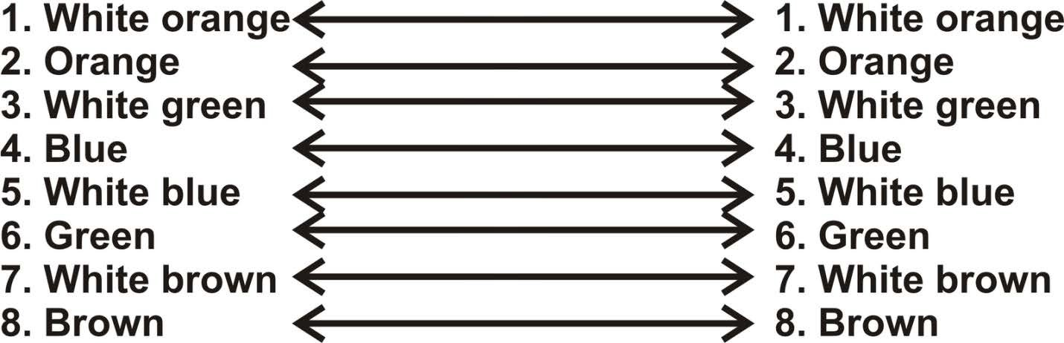

- Cross Cable

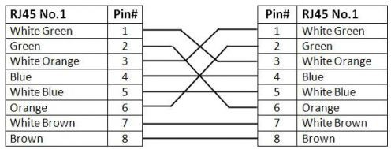

EXPERIMENT No. 2 WEEK NO: 2
Introduction to IP Addressing and Classes of IP Address
IPV4

Total IP Address Range of 1Pv4 is 0.0.0 .0

IP Addresses are divided into 5 Classes
to 255.255.255.255

CLASS | Class Ranges | Octet  Format | No. Networks & Hosts
A | 0.0.0.0 - 127.255.255.255 | N.H.H.H | 126 Networks & 16777214 Hosts per  Network
B | 128.0.0.0-  191.255.255.255 | N.N.H.H | 16384 Networks & 65534 Hosts per  Network
c | 192.0.0.0-  223.255.255.255 | N.N.N.H | 2097152 Networks & 254 Hosts per  Network
D | 224.0.0.0-  239.255.255.255 | Reserved for multicast traffic
E | 240.0.0.0-  255.255.255.255 | Reserved for Research and development

IP Address Class A, Class B, and Class C
Class A, Class B, and Class C are the three classes of addresses used on IP networks in common practice, with three exceptions as explained next.

IP Loopback Address
127.0.0.1 is the loopback address in IP. Loopback is a test mechanism of network adapters. Messages sent to do not get delivered to the network. Instead, the adapter intercepts all loopback messages and returns them to the sending application. IP applications often use this feature to test the behavior of their network interface.

As with broadcast, IP officially reserves the entire range from 127.0.0.0 through 127.255.255.255 for loopback purposes. Nodes should not use this range on the Internet, and it should not be considered part of the normal Class A range.

Zero Addresses
As with the loopback range, the address range from 0.0.0.0 through 0.255.255.255 should not be considered part of the normal Class A range.

Private Addresses
The IP standard defines specific address ranges within Class A, Class B, and Class C reserved for use by private networks (intranets). The table below lists these reserved ranges of the IP address space.

Class | Private start address | Private finish address
A | 10.0.0.0 | 10.255.255.255
B | 172.16.0.0 | 172.31.255.255
C | 192.168.0.0 | 192.168.255.255

Result:

EXPERIMENT No. 3 WEEK NO: 3

Subnetting Addresses, How to divide network into small Networks-Subnet Masks.

        - Subnetting is the process of Dividing a Single Network into Multiple smaller networks.
        - Converting Host bits into Network Bits i.e. Converting O's in to1's
        - Subnetting helps in minimizing the wastage of IP address

Subnetting can be performing in two ways.
- FLSM (Fixed Length Subnet Mask)
- VLSM (Variable Length subnet mask)

Subnetting can be done based on requirement.

          - Requirement of Hosts?
          - Requirement of Networks?

POWER TABLE:-
2h - 2 >= requirement 2• >=requirement

21 = 2 |  |  | 29 = 512 | 217 = 131072 | 2²⁵ = 33554432
 | 22 = 4 |  | 210 = 1024 | 218 = 262144 | 226 = 67108864
 | 23 = 8 |  | 211 = 2048 | 219 = 524288 | 227 = 134217728
 |  | 24 = 16 | 212 = 4096 | 2²⁰ = 1048576 | 228 = 268435456
 |  | 25 = 32 | 213 = 8192 | 2²¹ = 2097152 | 229 = 536870912
 |  | 26 = 64 | 214 = 16384 | 2²² = 4194304 | 230 = 1073741824
 |  | 27 = 128 | 215 = 32768 | 2²³ = 8388608 | 231 = 2147483648

VALUES IN SUBNET MASK
I Bit | Value | Mask
I 1 | 128 | 10000000
I 2 | 192 | 11000000 '
I 3 | 224 | 11100000  I
I 4 | 240
I 4 | 240 |  | I
I 5 | 248 | 11111000
I 6 | 252 | 11111100 '
I 7 | 254 | 11111110 ;  I
\ 8 | 255 -

11110000

-- 11111111 _):

(1). Fixed Length Subnet Mask (FLSM)

FLSM: Example-1

Req = 40 hosts using C - class address network 192. 168. 1.0

2^{h}- 2 >= req [Formula]

2⁶ -2>=40

64- 2>= 40

62 >= 40

- Host bits required (h) = 6

- Converted network Bits (n) =Total. H. Bits- req.
H. Bits

= 8 - 6 = 2

- Converted network Bits (n) = 2

Total. N. Bits = default N bits +converted N bits = 24 + 2 = 26

HostsfSubet = 2^{h} - 2 = 2⁶ -2 = 64-2

= 62 HostsjSubet

          - Subnets = 2^{n} = 2² = 4 Subnets

• Customized subnet mask = (26) = 255.255.255.192 Range: 2^{h} = 2⁶ = 64

Network ID Broadcast ID

• 192.168.1.0/26 | 192.168.1.63/26
• 192.168.1.64/26 | 192.168.1.127/26
• 192.168.1.128/26 | 192.168.1.191/26
• 192.168.1.192/26 | 192.168.1.255/26

FLSM: Example - 2

Req = 2000 hosts using A-class address network 10.0.0.0/8

2h- 2 >= req
211 - 2 >= 2000

2048 - 2 >= 2000

2046 >= 2000

            - Host bits required (h)= 11

            - Converted network Bits (n) = Total.H.Bits-req.H.Bits

= 24 -11=13

            - Converted network Bits (n) = 13

            - Total. N. Bits =default N bits +converted N bits = 8+ 13= /21

• HostsjSubnet = 2^{h}- 2 = 2¹¹-2 = 2048-2

= 2046 Hosts / Subnet

            - Subnets = 2" = 2¹³ = 8192 Subnets

            - Customized subnet mask = (121) = 255.255.248.0

B) Variable-Length Subnet Mask (VLSM):
➔VLSM is used for proper implementation of IP addresses which allows more than one subnet mask for a given network according to the individual needs
➔Logically dividing one network into smaller networks is called as Subnetting or VLSM
➔One subnet can be sub-netted for multiple times for efficient use.
➔Requires Classless Routing Protocols.

- Configuration Local Area Network :-

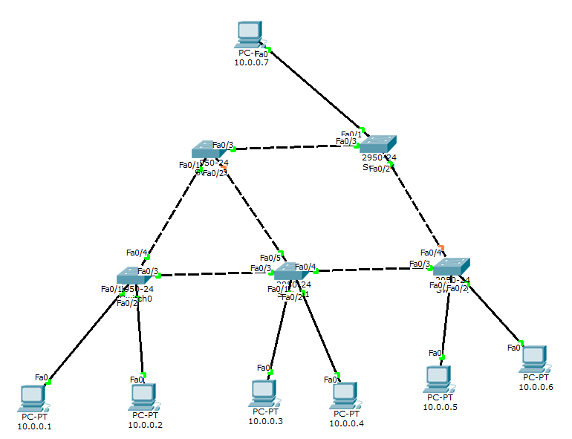

Result:

Output:

Exercise No: 4 Week No: 4 Week
Cisco - Router basic configuration:

Aim: To understand and configure the router by using packet tracer software

Connect the devices as shown in the diagram
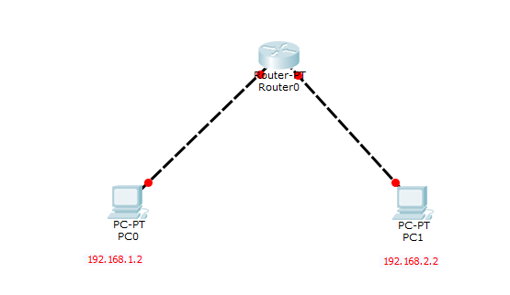
While configuring a router manually by using commands.
When you open the router continue with the CLI tab.
Continue with configuration dialog? [yes/no]:no
Router > enable
To privilege exact mode this is similar to route in your system.
Router # config t
To enter global configuration mode
Router (config) # hostname Router 0
To name the router
Router 0 (config)# enables secret class → password
To set password for privilege exact mode
Router 0 ( config)# line con 0
To configure password for line 0
Router ( config-line)# password cisco
Router ( config-line)# login
To enable password prompt
Router ( config-line)# exit
To return to global configuration
Now configure the password for virtual terminal line
Router 0 ( config ) # line vty 0 4
Router 0 (config-line) # password cisco
Router 0 (config-line) # login
To enable the password required
Router 0 (config-line) # exit
Router 0 (config) # interface fastEthernet 0/0
To configure the fast Ethernet
Enter an IP address
Router 0 (config-if)# ip address 192.168.1.1 255.255.255.0
Router 0 (config-if)# description Route 0 FastEthernet 0/0
Router 0 (config-if)# no shutdown
To start the interface ( to enable the interface )
Router 0 (config-if)# exit
To global configuration mode
Repeat the same by using FastEthernet 1/0
Router 0 (config) # interface fastEthernet 1/0
To configure the fast Ethernet
Enter an IP address
Router 0 (config-if)# ip address 192.168.2.1 255.255.255.0
Router 0 (config-if)# description Route 0 FastEthernet 1/0
Router 0 (config-if)# no shutdown
To start the interface ( to enable the interface )
Router 0 (config-if)# exit
Exit out of interface configuration mode
Exit out of global configuration mode
Router 0 (config)# exit
Router 0#
Privilege exact mode
Router 0# show running-config

To display the current configuration
You can see all the configurations you entered
Router 0# copy running-config startup-config
Destination filename [ startup-config]?
Building configuration…..
[OK]
Router 0#
Route configuration is now complete close the Router 0 window.
To configure PC 0
Go to the desktop tab→ IP configuration
We will set a static IP
Set IP address 192.168.1.2
Subnet Mask 255.255.255.0
Default Gateway 192.168.1.1
Close the PC 0 window
To configure PC 1
Go to the desktop tab→ IP configuration
We will set a static IP
Set IP address 192.168.2.2
Subnet Mask 255.255.255.0
Default Gateway 192.168.2.1
Close the PC 1 window
Now you can see the green dots near the cables which are connected to the devices, it means that they are connected.
Let’s try pinging PC 1 from PC 0
Goto PC 0→ desktop→command promt
PC> ip config
IP Address
Subnet Mask
Default Gateway
PC> ping 192.168.2.2
The ping should succeed.
Visually you can see the ping with Simulation mode

Bottom right corner you can see two mode
- Real time
- Simulation
In Simulation mode
Drag the envelope and assign the envelope to PC 0 and PC 1
Click auto capture/play → to begin ping simulator.

Output:

Result:

EXPERIMENT No. 5 WEEK NO: 5 & 6 Week

Cisco Switch Configuration using packet tracer simulator:

AIM: - To Configure the Switch-1 & Switch-2 with Vlan 10 and Vlan 20, Switch-1 of Vlan 10 must communicate with Switch-2 of Vlan 10 and Switch-1 of Vlan 20 must communicate with Switch-2 of vlan 20 by using packet tracer software.

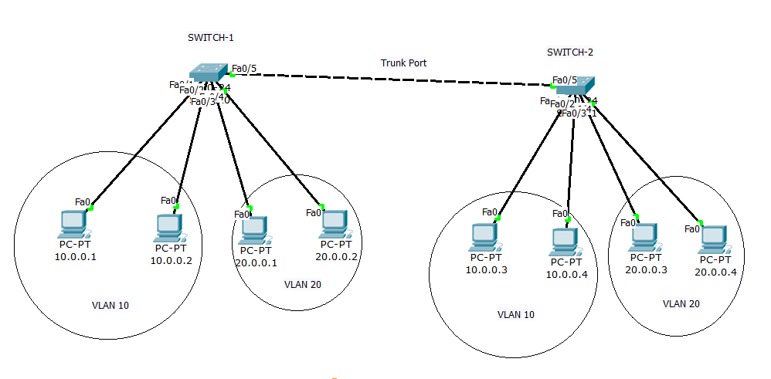

Configuration: - SWITCH-1 Switch-1>enable
Switch-1#configure terminal
Switch-1(config)#vlan 10
Switch-1(config-vlan)#exit
Switch-1(config)#vlan 20
Switch-1(config-vlan)#exit
Switch-1(config)#int f0/1
Switch-1(config-if)#switchport mode access
Switch-1(config-if)#switchport access vlan 10
Switch-1(config-if)#exit
Switch-1(config)#int f0/2

Switch-1(config-if)#switchport mode access
Switch-1(config-if)#switchport access vlan 10
Switch-1(config-if)#exit
Switch-1(config)#int f0/3

Switch-1(config-if)#switchport mode access
Switch-1(config-if)#switchport access vlan 20
Switch-1(config-if)#exit
Switch-1(config)#int f0/4

Switch-1(config-if)#switchport mode access
Switch-1(config-if)#switchport access vlan 20
Switch-1(config-if)#exit
Switch-1(config)#int f0/5

Switch-1(config-if)#switchport mode trunk
Switch-1(config-if)#exit
Configuration:- SWITCH-2 Switch-2>enable
Switch-2#configure terminal
Switch-2(config)#vlan 10
Switch-2(config-vlan)#exit
Switch-2(config)#vlan 20
Switch-2(config-vlan)#exit
Switch-2(config)#int f0/1
Switch-2(config-if)#switchport mode access
Switch-2(config-if)#switchport access vlan 10
Switch-2(config-if)#exit
Switch-2(config)#int f0/2
Switch-2(config-if)#switchport mode access
Switch-2(config-if)#switchport access vlan 10
Switch-2(config-if)#exit
Switch-2(config)#int f0/3

Switch-2(config-if)#switchport mode access
Switch-2(config-if)#switchport access vlan 20
Switch-2(config-if)#exit
Switch-2(config)#int f0/4
Switch-2(config-if)#switchport mode access
Switch-2(config-if)#switchport access vlan 20
Switch-2(config-if)#exit
Switch-2(config)#int f0/5
Switch-2(config-if)#switchport mode trunk
Switch-2(config-if)#exit
Verification:

Pc-1>ping 10.0.0.3

Reply…..

Pc-3>ping 20.0.0.3

Reply…….

Output:

Result:
Switch Communication:

Aim: To Communicate between only VLAN 10 and provide restriction to communicate VLAN 20

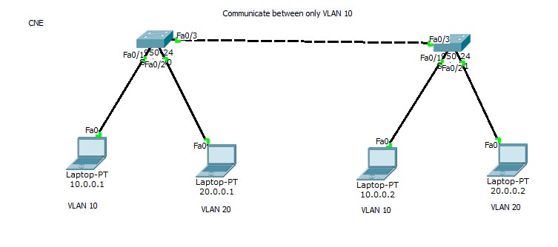

Sw1(conf)#int f0/3

Sw1(conf-if)#switchport mode trunk
Sw1(conf-if)#switchport trunk allowed vlan 10
Sw1(conf-if)#exit
Sw2(conf)# int f0/3

Sw2(conf-if)#switchport mode trunk
Sw2(conf-if)#switchport trunk allowed vlan 10
Sw2(conf-if)#exit

Output:-

Result:

Multilayer Switch Configuration:

Note: - A Multilayer Switch is used to communicate between different VLAN's

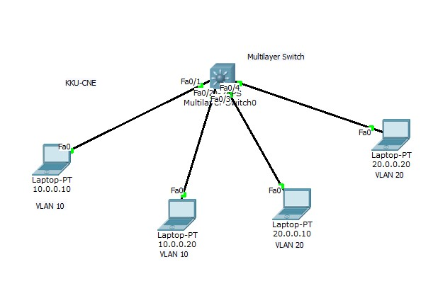

Configuration of Multilayer Switch:-

Switch(conf)#int f0/1

Switch(conf-if)#switchport mode access
Switch(conf-if)switchport access vlan 10
Switch(conf-if)exit
Switch(conf)#int f0/2

Switch(conf-if)#switchport mode access
Switch(conf-if)switchport access vlan 10
Switch(conf-if)exit
Switch(conf)#int f0/3
Switch(conf-if)#switchport mode access
Switch(conf-if)switchport access vlan 20
Switch(conf-if)exit
Switch(conf)#int f0/1

Switch(conf-if)#switchport mode access
Switch(conf-if)switchport access vlan 20
Switch(conf-if)exit
Switch(conf)# ip routing (This command is used to enable routing in multilayer switch)
Switch(conf) int vlan 10
Switch(conf-vlan)#ip add 10.0.0.254 255.255.255.0
Switch(conf-vlan)#no shut
Switch(conf-vlan)#exit
Switch(conf) int vlan 20
Switch(conf-vlan)#ip add 20.0.0.254 255.255.255.0
Switch(conf-vlan)#no shut
Switch(conf-vlan)#exit

OUTPUT:-

Result:

Communication Between different LANs:
Aim: To communicate vlan 10 and vlan 20 with help of Multilayer switch

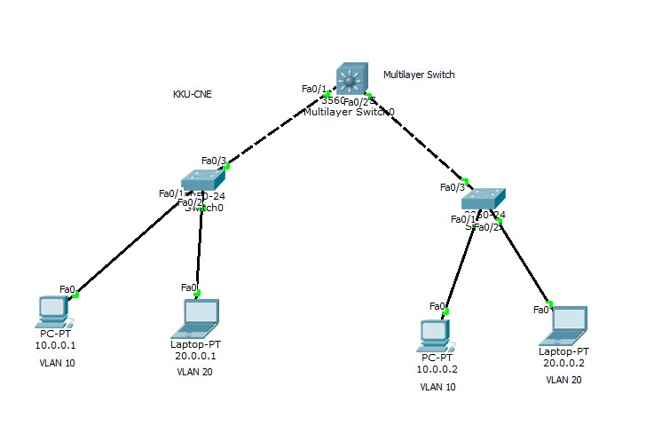

Configuration of Multilayer Switch:-
Switch(conf)# ip routing
Switch(conf) int vlan 10
Switch(conf-vlan)#ip add 10.0.0.254 255.255.255.0
Switch(conf-vlan)#no shut
Switch(conf-vlan)#exit
Switch(conf) int vlan 20
Switch(conf-vlan)#ip add 20.0.0.254 255.255.255.0
Switch(conf-vlan)#no shut
Switch(conf-vlan)#exit
Switch(conf)#int f0/1
Switch(conf-if)#switchport mode trunk

Switch(conf-if)#switchport trunk allowed vlan 10,20
Switch(conf-if)#exit
Switch(conf)#int f0/2

Switch(conf-if)#switchport mode trunk

Switch(conf-if)#switchport trunk allowed vlan 10,20
Switch(conf-if)#exit
Configuration of Switch-1:-

Switch(conf)#int f0/1

Switch(conf-if)#switchport mode access
Switch(conf-if)switchport access vlan 10
Switch(conf-if)exit
Switch(conf)#int f0/2
Switch(conf-if)#switchport mode access
Switch(conf-if)switchport access vlan 20
Switch(conf-if)exit
Switch(conf)#int f0/3
Switch(conf-if)#switchport mode trunk
Switch(conf-if)switchport trunk allowed vlan 10,20
Switch(conf-if)exit
Configuration of Switch-2:-
Switch(conf)#int f0/1

Switch(conf-if)#switchport mode access
Switch(conf-if)switchport access vlan 10
Switch(conf-if)exit
Switch(conf)#int f0/2

Switch(conf-if)#switchport mode access
Switch(conf-if)switchport access vlan 20
Switch(conf-if)exit
Switch(conf)#int f0/3

Switch(conf-if)#switchport mode trunk
Switch(conf-if)switchport trunk allowed vlan 10,20
Switch(conf-if)exit

OUTPUT:-

Result:

Aim: - To identify the Root-bridge, mac-address, priority, cost and speed of all switches

Verification: - DP, RP. NDP, Root-bridge

Result:
Experiment No: 6 Week No: 7 Week

Routing Protocol – Static Routing Protocol

Aim: To understand the concept of Static Routing Protocols.

Using Router configure Static Routing Protocol
- Connecting devices with copper cross-over.
- Configuration of gateway for Routers that will be the first or last IP (1 to 254) in a Network.
- Configuration of End Devices ( IP, Subnet Mask, Default gateway)
- Build the Routing Table.(Destination Network, Mask and NextHop)
- Check the Configuration.

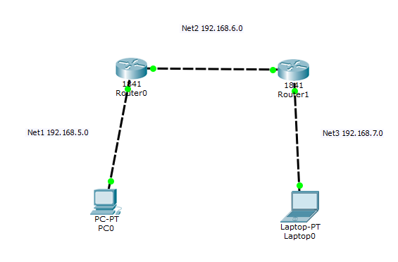

Result:

Output:

Exercise No: 7 Week No: 8 Week

ROUTING PROTOCOLS – Dynamic Routing Protocols

(RIP CONFIGURATION)
Aim: To Understanding the Dynamic Routing table updates using the Routing Protocol (RIP).

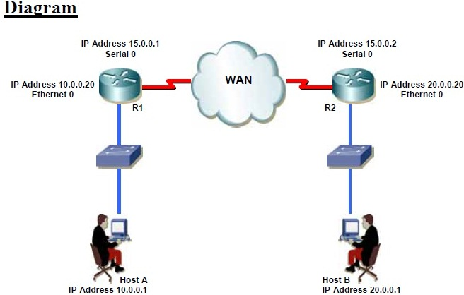
Procedure
1. Configuring & Assigning the IP addresses on the routers R1 & R2.
2. Check the routing table on both the routers.
3. Enable the RIP protocol on both routers so that hosts on the both routers can communicate with each other.
4. Verifying the Routing protocols on the Router.
5. Check the routing table on both the routers after enabling the RIP on both sides.
6. Verifying the connection of both hosts.

Configuration
Step 1(A): Assigning the IP addresses on the Ethernet & Serial Interfaces of Router R1 as shown in figure (Refer Static Routing).
Step 1(B): Assigning the IP addresses on the Ethernet & Serial Interfaces of Router R2 as shown in figure (Refer Static Routing).
Step 2(A): Check the Routing table of the Router R1.
R1#sh ip route
Step 2(B): Check the Routing table of the Router R2.
R2#sh ip route
Step 3(A): Enable the RIP protocol on the Router R1.
R1(config)#router rip
R1(config-router)#network 10.0.0.0 (Network to be advertised which is Directly Connected)
R1(config-router)#network 15.0.0.0 (Network to be advertised which is Directly Connected)
Step 3(B): Enable the RIP protocol on the Router R2.
R2(config)#router rip
R2(config-router)#network 20.0.0.0 (Network to be advertised which is Directly Connected)
R2(config-router)#network 15.0.0.0 (Network to be advertised which is Directly Connected)
Step 4(A): Check the Routing Protocol on the Router R1.
R1#show ip protocols
Step 4(B): Check the Routing Protocol on the Router R2.
R2#show ip protocols
Step 5(A): Check the Routing table of the Router R1 after enabling RIP.
R1#sh ip route
Step 5(B): Check the Routing table of the Router R2 after enabling RIP.
R2#sh ip route
Step 6: Verifying the connection of Host ‘A’ & Host ‘B’.
C:\>ping 20.0.0.1

EIGRP Configuration

Aim: To Understanding the Routing Updates using the Dynamic Routing Protocol (EIGRP).

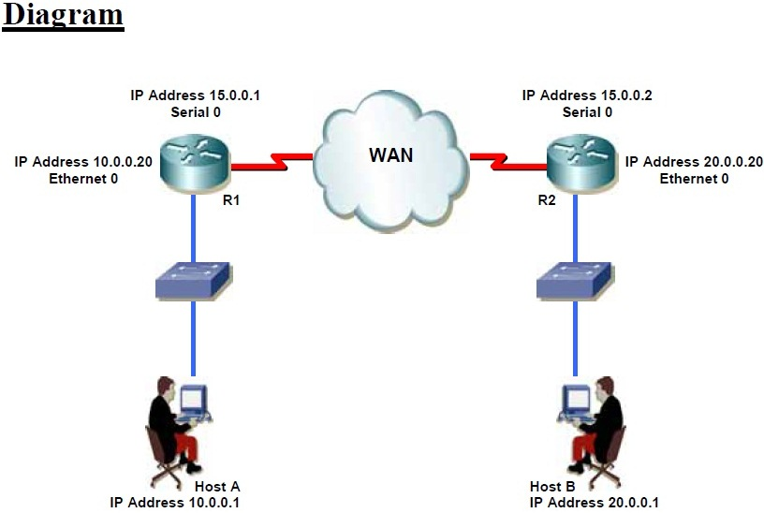
Procedure
1. Configuring & Assigning the IP addresses on the routers R1 & R2.
2. Check the routing table on both the routers.
3. Enable the EIGRP protocol on both routers so that hosts on the both routers can communicate with each other.
4. Verifying the Routing protocols on the Router.
5. Check the routing table on both the routers after enabling the EIGRP on both sides.
6. Verifying the connection of both hosts.
Configuration
Step 1(A): Assigning the IP addresses on the Ethernet & Serial Interfaces of Router R1 as shown in figure (Refer Static Routing).
Step 1(B): Assigning the IP addresses on the Ethernet & Serial Interfaces of Router R2 as shown in figure (Refer Static Routing).
Step 2(A): Check the Routing table of the Router R1.
R1#sh ip route
Step 2(B): Check the Routing table of the Router R2.
R2#sh ip route
Step 3(A): Enable the EIGRP protocol on the Router R1.
R1(config)#router eigrp 10
R1(config-router)#network 10.0.0.0 (Network to be advertised which is Directly Connected)
R1(config-router)#network 15.0.0.0 (Network to be advertised which is Directly Connected)
Step 3(B): Enable the EIGRP protocol on the Router R2.
R2(config)#router eigrp 10
R2(config-router)#network 20.0.0.0 (Network to be advertised which is Directly Connected)
R2(config-router)#network 15.0.0.0 (Network to be advertised which is Directly Connected)
Step 4(A): Check the Routing Protocol on the Router R1.
R1#show ip protocols
Step 4(B): Check the Routing Protocol on the Router R2.
R2#show ip protocols
Step 5(A): Check the Routing table of the Router R1 after enabling EIGRP.
R1#sh ip route
Step 5(B): Check the Routing table of the Router R2 after enabling EIGRP.
R2#sh ip route
Step 6: Verifying the connection of Host ‘A’ & Host ‘B’.
C:\>ping 20.0.0.1

OSPF - Single Area Configuration

Aim: To Understanding the Routing Updates process using the Open Shortest Path First (OSPF) in a single area.

Procedure
1. Configuring & Assigning the IP addresses on the routers R1 & R2.
2. Check the routing table on both the routers.
3. Enable the OSPF protocol on both routers so that hosts on the both routers can communicate with each other.
4. Verifying the Routing protocols on the Router.
5. Check the routing table on both the routers after enabling the OSPF on both sides.
6. Verifying the OSPF neighbors on the routers.
7. Verifying the OSPF interfaces on the routers.
8. Verifying the OSPF database on the routers.
9. Verifying the connection of both hosts.

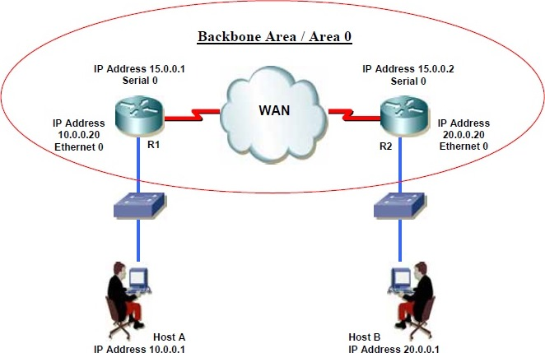

Configuration
Step 1(A): Assigning the IP addresses on the Ethernet & Serial Interfaces of Router R1 as shown in figure.
Step 1(B): Assigning the IP addresses on the Ethernet & Serial Interfaces of Router R2 as shown in figure.
Step 2(A): Check the Routing table of the Router R1.
R1#sh ip route
Step 2(B): Check the Routing table of the Router R2.
R2#sh ip route
Step 3(A): Enable the OSPF protocol on the Router R1.
R1(config)#router ospf 64
R1(config-router)#network 10.0.0.0 0.255.255.255 area 0
(Directly Connected Network, its Wild card mask, & area)
R1(config-router)#network 15.0.0.0 0.255.255.255 area 0
(Directly Connected Network, its Wild card mask, & area)
Step 3(B): Enable the OSPF protocol on the Router R2.
R2(config)#router ospf 65
R2(config-router)#network 15.0.0.0 0.255.255.255 area 0
(Directly Connected Network, its Wild card mask, & area)
R2(config-router)#network 20.0.0.0 0.255.255.255 area 0
(Directly Connected Network, its Wild card mask, & area)
Step 4(A): Check the Routing Protocol on the Router R1.
R1#show ip protocols
Step 4(B): Check the Routing Protocol on the Router R2.
R2#show ip protocols
Step 5(A): Check the Routing table of the Router R1 after enabling OSPF.
R1#sh ip route
Step 5(B): Check the Routing table of the Router R2 after enabling OSPF.
R2#sh ip route
Step 6: Verifying the OSPF neighbors on the Router
R#show ip ospf neighbor

Step 7: Verifying the OSPF interfaces on the Router
R#show ip ospf interface
Step 8: Verifying the OSPF database on the Router
R1#show ip ospf database
Step 9: Verifying the connection of Host ‘A’ & Host ‘B’.
C:\>ping 20.0.0.1

Result:

Output:

Experiment. No: 8 Week No: 9 Week

Configure Cisco Router – Secure Device Manager

Aim: To understand and configure the cisco router by using Secure Device Manager

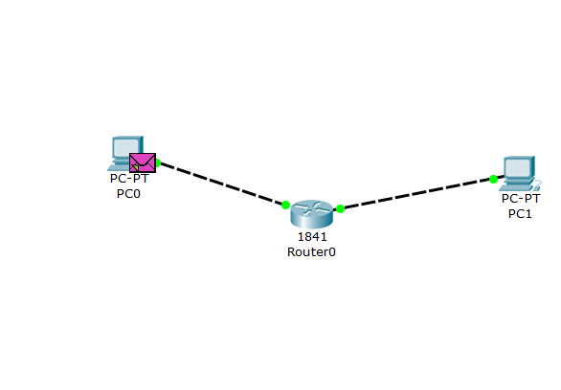

Necessary Router Configuration

Step 1:- SDM uses HTTPS protocol for connectivity. Enable the HTTP and HTTPS
servers on router.
Router# configure terminal
Enter configuration commands, one per line. End with CNTL/Z.
Router(config)# ip http server
Router(config)# ip http secure-server
Router(config)# ip http authentication local
Router(config)# ip http timeout-policy idle 600 life 86400 requests 10000

Step 2:- Proper authentication is required to connect with router via SDM. Create a user account with following in global configuration mode, replacing username and password with the word that you want to use:
Router(config)# username username privilege 15 secret 0 password
For example, if you chose the username admin and the password vinita, you should enter the following:
Router(config)# username admin privilege 15 secret 0 vinita

Step 3:- Configure SSH and Telnet for local login and privilege level 15 with the following commands:
Router(config)# line vty 0 4
Router(config-line)# privilege level 15
Router(config-line)# login local
Router(config-line)# transport input telnet ssh
Router(config-line)# exit

Step 4:- Assign IP address to Fast Ethernet interface. PC will connect with router via this interface.
Router(config)#interface fastethernet 0/0
Router(config-if)#ip address 192.168.1.1 255.255.255.0
Router(config-if)#no shutdown

Necessary connectivity requirement
If you are connecting PC directly to the Router use cross over cable. If you are connecting PC with Router via Switch or hub use straight cable.
Use Router's first available Ethernet or FastEthernet port for connectivity.
Make sure Router and PC remain in the same subnet. IP address configured on PC's lan card and Ethernet interface of Router that is used for connectivity belong to same network.

Accessing SDM
Cisco SDM is stored in flash memory of router. It can be invoked by executing an HTML file in the router archive, which then would load the signed Cisco SDM Java file. To launch Cisco SDM, use the following steps:

Step 1 :- Open your browser and enter the following URL:
https://<router IP address>
In our example it would be
https://192.168.1.1
https:// is used for secure connection. SSL protocol is required for secure connection.
http:// is used for unsecure connection where SSL is not available.

Step 2 :- As I have already mentioned earlier in this article that SDM requires authentication in order to connect with router. We have created necessary user account in previous section of this article. Enter username and password that we have created.

Output:

Result:

EXPERIMENT No. 9 Week No: 10
VLAN Switching:

Aim: - To understand the Inter vlan routing used to communicate between different vlan’s

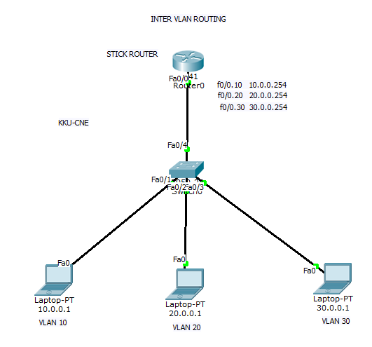

Configuration of Switch:-
Switch(conf)#vlan 10
Switch(conf-vlan)#exit
Switch(conf)#vlan 20 Switch(conf-vlan)#exit
Switch(conf)#vlan 20
Switch(conf-vlan)#exit
Switch(conf)#int f0/1
Switch(conf-if)#switchport mode access
Switch(conf-if)switchport access vlan 10
Switch(conf-if)exit
Switch(conf)#int f0/2

Switch(conf-if)#switchport mode access
Switch(conf-if)switchport access vlan 20
Switch(conf-if)exit
Switch(conf)#int f0/3

Switch(conf-if)#switchport mode access
Switch(conf-if)switchport access vlan 30
Switch(conf-if)exit
Switch(conf)#int f0/4

Switch(conf-if)#switchport mode trunk
Switch(conf-if)switchport trunk allowed vlan all
Switch(conf-if)exit
Configuration of Router:-
Router(conf)#int f0/0
Router(conf-if)#no shut
Router(conf-if)#exit
Router(conf)#int f0/0.10

Router(conf-subif)#encapsulation dot1q 10

Router(conf-subif)#ip add 10.0.0.254 255.255.255.0
Router(conf-subif)#exit
Router(conf)#int f0/0.20

Router(conf-subif)#encapsulation dot1q 20

Router(conf-subif)#ip add 20.0.0.254 255.255.255.0
Router(conf-subif)#exit
Router(conf)#int f0/0.30

Router(conf-subif)#encapsulation dot1q 30

Router(conf-subif)#ip add 30.0.0.254 255.255.255.0
Router(conf-subif)#exit

OUTPUT:-

Result:

VLAN Routing with Different VLANs

Aim: - To understand and Configure the Router with Inter vlan routing and all vlan’s must communicate in the network.

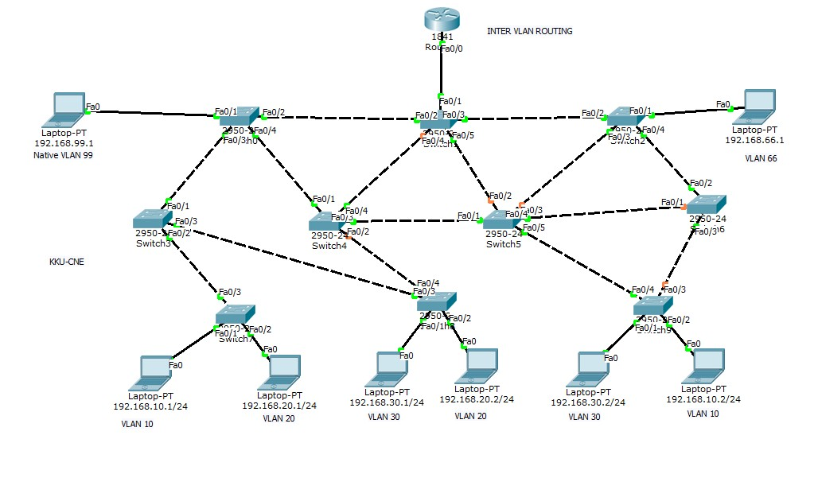

OUTPUT:-

Result:

EXPERIMENT No. 10 Week No: 11 Week

Configuration of Dynamic Host Configuration Protocol and NAT

Topology Diagram

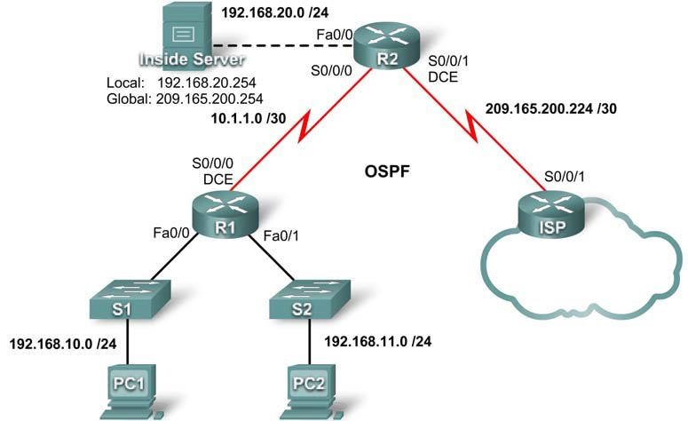

Addressing Table

Device | Interface | IP Address | Subnet Mask
R1 | S0/0/0 | 10.1.1.1 | 255.255.255.252
R1 | Fa0/0 | 192.168.10.1 | 255.255.255.0
R1 | Fa0/1 | 192.168.11.1 | 255.255.255.0
R2 | S0/0/0 | 10.1.1.2 | 255.255.255.252
R2 | S0/0/1 | 209.165.200.225 | 255.255.255.252
R2 | Fa0/0 | 192.168.20.1 | 255.255.255.0
ISP | S0/0/1 | 209.165.200.226 | 255.255.255.252

Learning Objectives

Upon completion of this lab, you will be able to:

  - Prepare the network
  - Perform basic router configurations
  - Configure a Cisco IOS DHCP server
  - Configure static and default routing
  - Configure static NAT
  - Configure dynamic NAT with a pool of addresses
  - Configure NAT overload

Scenario

In this lab, you will configure the DHCP and NAT IP services. One router is the DHCP server. The other router forwards DHCP requests to the server. You will also configure both static and dynamic NAT configurations, including NAT overload. When you have completed the configurations, verify the connectivity between the inside and outside addresses.

Task 1: Perform Basic Router Configurations

Configure the R1, R2, and ISP routers according to the following guidelines:

  - Configure the device hostname.
  - Disable DNS lookup.
  - Configure a privileged EXEC mode password.
  - Configure a message-of-the-day banner.
  - Configure a password for the console connections.
  - Configure a password for all vty connections.
  - Configure IP addresses on all routers. The PCs receive IP addressing from DHCP later in the activity.
  - Enable OSPF with process ID 1 on R1 and R2. Do not advertise the 209.165.200.224/27 network.

Task 2: Configure a Cisco IOS DHCP Server

Step 1: Exclude statically assigned addresses.

The DHCP server assumes that all IP addresses in a DHCP address pool subnet are available for assigning to DHCP clients. You must specify the IP addresses that the DHCP server should not assign to clients. These IP address are usually static addresses reserved for the router interface, switch management IP address, servers, and local network printer. The ip dhcp excluded-address command prevents the router from assigning IP addresses within the configured range. The following commands exclude the first 10 IP addresses from each pool for the LANs attached to R1. These addresses will not be assigned to any DHCP clients.

R1(config)#ip dhcp excluded-address 192.168.10.1 192.168.10.10
R1(config)#ip dhcp excluded-address 192.168.11.1 192.168.11.10

Step 2: Configure the pool.

Create the DHCP pool using the ip dhcp pool command and name it R1Fa0.

R1(config)#ip dhcp pool R1Fa0

Specify the subnet to use when assigning IP addresses. DHCP pools automatically associate with an interface based on the network statement. The router now acts as a DHCP server, handing out addresses in the 192.168.10.0/24 subnet starting with 192.168.10.1.

R1(dhcp-config)#network 192.168.10.0 255.255.255.0

Configure the default router and domain name server for the network. Clients receive these settings via DHCP, along with an IP address.

R1(dhcp-config)#dns-server 192.168.11.5
R1(dhcp-config)#default-router 192.168.10.1

Note: There is not a DNS server at 192.168.11.5. You are configuring the command for practice only.

R1(config)#ip dhcp pool R1Fa1
R1(dhcp-config)#network 192.168.11.0 255.255.255.0
R1(dhcp-config)#dns-server 192.168.11.5
R1(dhcp-config)#default-router 192.168.11.1

Step 3: Verify the DHCP configuration.

You can verify the DHCP server configuration in several different ways. The most basic way is to configure a host on the subnet to receive an IP address via DHCP. You can then issue commands on the router to get more information. The show ip dhcp binding command provides information on all currently assigned DHCP addresses. For instance, the following output shows that the IP address 192.168.10.11 has been assigned to MAC address 3031.632e.3537.6563. The IP lease expires on September 14, 2007 at 7:33 pm.

R1#show ip dhcp binding
IP address Client-ID/ Lease expiration Type Hardware address
192.168.10.11 0007.EC66.8752 -- Automatic
      - 00E0.F724.8EDA -- Automatic

Task 3: Configure Static and Default Routing

ISP uses static routing to reach all networks beyond R2. However, R2 translates private addresses into public addresses before sending traffic to ISP. Therefore, ISP must be configured with the public addresses that are part of the NAT configuration on R2. Enter the following static route on ISP:

ISP(config)#ip route 209.165.200.240 255.255.255.240 serial 0/0/1

This static route includes all addresses assigned to R2 for public use. Configure a default route on R2 and propagate the route in OSPF.
R2(config)#ip route 0.0.0.0 0.0.0.0 209.165.200.226
R2(config)#router ospf 1
R2(config-router)#default-information originate

Allow a few seconds for R1 to learn the default route from R2 and then check the R1 routing table. Alternatively, you can clear the routing table with the clear ip route * command. A default route pointing to R2 should appear in the R1 routing table. From R1, ping the serial 0/0/1 interface on R2 (209.165.200.225). The pings should be successful. Troubleshoot if the pings fail.

Task 4: Configure Static NAT

Step 1: Statically map a public IP address to a private IP address.
The inside server attached to R2 is accessible by outside hosts beyond ISP. Statically assign the public IP address 209.165.200.254 as the address for NAT to use to map packets to the private IP address of the inside server at 192.168.20.254.

R2(config)#ip nat inside source static 192.168.20.254 209.165.200.254

Step 2: Specify inside and outside NAT interfaces.
Before NAT can work, you must specify which interfaces are inside and which interfaces are outside.
R2(config)#interface serial 0/0/1 R2(config-if)#ip nat outside R2(config-if)#interface fa0/0 R2(config-if)#ip nat inside

Step 3: Verify the static NAT configuration.

From ISP, ping the public IP address 209.165.200.254.
Task 5: Configure Dynamic NAT with a Pool of Addresses

While static NAT provides a permanent mapping between an internal address and a specific public address, dynamic NAT maps private IP addresses to public addresses. These public IP addresses come from a NAT pool.

Step 1: Define a pool of global addresses.
Create a pool of addresses to which matched source addresses are translated. The following command creates a pool named MY-NAT-POOL that translates matched addresses to an available IP address in the 209.165.200.241 - 209.165.200.246 range.

R2(config)#ip nat pool MY-NAT-POOL 209.165.200.241 209.165.200.246 netmask 255.255.255.248

Step 2: Create a standard access control list to identify which inside addresses are translated.
R2(config)#ip access-list extended NAT
R2(config-std-nacl)#permit ip 192.168.10.0 0.0.0.255 any
R2(config-std-nacl)#permit ip 192.168.11.0 0.0.0.255 any

Step 3: Establish dynamic source translation by binding the pool with the access control list.
A router can have more than one NAT pool and more than one ACL. The following command tells the router which address pool to use to translate hosts that are allowed by the ACL.

R2(config)#ip nat inside source list NAT pool MY-NAT-POOL

Step 4: Specify inside and outside NAT interfaces.
You have already specified the inside and outside interfaces for your static NAT configuration. Now add the serial interface linked to R1 as an inside interface.

R2(config)#interface serial 0/0/0
R2(config-if)#ip nat inside

Step 5: Verify the configuration.

Ping ISP from PC1 and PC2. Then use the show ip nat translations command on R2 to verify NAT.

R2#show ip nat translations
Pro | Inside global | Inside local | Outside | local | Outside global
--- | 209.165.200.241 | 192.168.10.11 | --- |  | ---
--- | 209.165.200.242 | 192.168.11.11 | --- |  | ---
--- | 209.165.200.254 | 192.168.20.254 | --- |  | ---

Task 6: Configure NAT Overload

In the previous example, what would happen if you needed more than the six public IP addresses that the pool allows?
By tracking port numbers, NAT overloading allows multiple inside users to reuse a public IP address. In this task, you will remove the pool and mapping statement configured in the previous task. Then you will configure NAT overload on R2 so that all internal IP addresses are translated to the R2 S0/0/1 address when connecting to any outside device.

Step 1: Remove the NAT pool and mapping statement.

Use the following commands to remove the NAT pool and the map to the NAT ACL.

R2(config)#no ip nat pool MY-NAT-POOL 209.165.200.241 209.165.200.246 netmask 255.255.255.248
R2(config)#no ip nat inside source list NAT pool MY-NAT-POOL

If you receive the following message, clear your NAT translations.

%Pool MY-NAT-POOL in use, cannot destroy R2#clear ip nat translation *

Step 2: Configure PAT on R2 using the serial 0/0/1 interface public IP address.

The configuration is similar to dynamic NAT, except that instead of a pool of addresses, the interface keyword is used to identify the outside IP address. Therefore, no NAT pool is defined. The overload keyword enables the addition of the port number to the translation.

Because you already configured an ACL to identify which inside IP addresses to translate as well as which interfaces are inside and outside, you only need to configure the following:

R2(config)#ip nat inside source list NAT interface S0/0/1 overload

Step 3: Verify the configuration.

Ping ISP from PC1 and PC2. Then use the show ip nat translations command on R2 to verify NAT.

R2#show ip nat translations
Pro Inside global Inside local Outside local Outside global icmp 209.165.200.225:3 192.168.10.11:3 209.165.200.226:3
209.165.200.226:3
icmp 209.165.200.225:1024192.168.11.11:3 209.165.200.226:3
209.165.200.226:1024
--- 209.165.200.254 192.168.20.254 --- ---

Note: In the previous task, you could have added the keyword overload to the ip nat inside source list NAT pool MY-NAT-POOL command to allow for more than six concurrent users.

Task 7: Document the Network

On each router, issue the show run command and capture the configurations.
Task 1: Prepare the Network

Step 1: Cable a network that is similar to the one in the topology diagram.
You can use any current router in your lab as long as it has the required interfaces shown in the topology. Note: If you use a 1700, 2500, or 2600 series router, the router outputs and interface descriptions may look different.

Step 2: Clear all existing configurations on the routers.

Task 2: Perform Basic Router Configurations

Configure the R1, R2, and ISP routers according to the following guidelines:

        - Configure the device hostname.

        - Disable DNS lookup.

        - Configure a privileged EXEC mode password.

        - Configure a message-of-the-day banner.

        - Configure a password for the console connections.

        - Configure a password for all vty connections.

        - Configure IP addresses on all routers. The PCs receive IP addressing from DHCP later in the lab.

        - Enable OSPF with process ID 1 on R1 and R2. Do not advertise the 209.165.200.224/27 network.

Note: Instead of attaching a server to R2, you can configure a loopback interface on R2 to use the IP address 192.168.20.254/24. If you do this, you do not need to configure the Fast Ethernet interface.

Task 3: Configure a Cisco IOS DHCP Server

Cisco IOS software supports a DHCP server configuration called Easy IP. The goal for this lab is to have devices on the networks 192.168.10.0/24 and 192.168.11.0/24 request IP addresses via DHCP from R2.

Step 1. Exclude statically assigned addresses.

The DHCP server assumes that all IP addresses in a DHCP address pool subnet are available for assigning to DHCP clients. You must specify the IP addresses that the DHCP server should not assign to clients. These IP addresses are usually static addresses reserved for the router interface, switch management IP address, servers, and local network printer. The ip dhcp excluded-address command prevents the router from assigning IP addresses within the configured range. The following commands exclude the first 10 IP addresses from each pool for the LANs attached to R1. These addresses will not be assigned to any DHCP clients.

R2(config)#ip dhcp excluded-address 192.168.10.1 192.168.10.10
R2(config)#ip dhcp excluded-address 192.168.11.1 192.168.11.10

Step 2. Configure the pool.

Create the DHCP pool using the ip dhcp pool command and name it R1Fa0.

R2(config)#ip dhcp pool R1Fa0

Specify the subnet to use when assigning IP addresses. DHCP pools automatically associate with an interface based on the network statement. The router now acts as a DHCP server, handing out addresses in the 192.168.10.0/24 subnet starting with 192.168.10.1.

R2(dhcp-config)#network 192.168.10.0 255.255.255.0

Configure the default router and domain name server for the network. Clients receive these settings via DHCP, along with an IP address.

R2(dhcp-config)#dns-server 192.168.11.5
R2(dhcp-config)#default-router 192.168.10.1

Note: There is not a DNS server at 192.168.11.5. You are configuring the command for practice only. Because devices from the network 192.168.11.0/24 also request addresses from R2, a separate pool must be created to serve devices on that network. The commands are similar to the commands shown above:

R2(config)#ip dhcp pool R1Fa1
R2(dhcp-config)#network 192.168.11.0 255.255.255.0

R2(dhcp-config)#dns-server 192.168.11.5
R2(dhcp-config)#default-router 192.168.11.1

Step 3. Configure a helper address.

Network services such as DHCP rely on Layer 2 broadcasts to function. When the devices providing these services exist on a different subnet than the clients, they cannot receive the broadcast packets. Because the DHCP server and the DHCP clients are not on the same subnet, configure R1 to forward DHCP broadcasts to R2, which is the DHCP server, using the ip helper-address interface configuration command.

Notice that ip helper-address must be configured on each interface involved.

R1(config)#interface fa0/0
R1(config-if)#ip helper-address 10.1.1.2
R1(config)#interface fa0/1
R1(config-if)#ip helper-address 10.1.1.2

Step 4. Verify the DHCP configuration.

You can verify the DHCP server configuration in several different ways. The most basic way is to configure a host on the subnet to receive an IP address via DHCP. You can then issue commands on the router to get more information. The show ip dhcp binding command provides information on all currently assigned DHCP addresses. For instance, the following output shows that the IP address 192.168.10.11 has been assigned to MAC address 3031.632e.3537.6563. The IP lease expires on September 14, 2007 at 7:33 p.m.

R1#show ip dhcp binding
Bindings from all pools not associated with VRF:
IP address Client-ID/ Lease expiration Type
Hardware address/ User name
192.168.10.11 0063.6973.636f.2d30. Sep 14 2007 07:33 PM Automatic
3031.632e.3537.6563.
2e30.3634.302d.566c.
31

The show ip dhcp pool command displays information on all currently configured DHCP pools on the router. In this output, the pool R1Fa0 is configured on R1. One address has been leased from this pool. The next client to request an address will receive 192.168.10.12.

R2#show ip dhcp pool Pool R1Fa0 :
Utilization mark (high/low) : 100 / 0 Subnet size (first/next) : 0 / 0 Total addresses : 254
Leased addresses : 1
Pending event : none
1 subnet is currently in the pool :
Current index | IP address range |  | Leased addresses
192.168.10.12 | 192.168.10.1 | - 192.168.10.254 | 1

The debug ip dhcp server events command can be extremely useful when troubleshooting DHCP leases with a Cisco IOS DHCP server. The following is the debug output on R1 after connecting a host. Notice that the highlighted portion shows DHCP giving the client an address of 192.168.10.12 and mask of 255.255.255.0

*Sep 13 21:04:18.072: DHCPD: Sending notification of DISCOVER:
*Sep 13 21:04:18.072: DHCPD: htype 1 chaddr 001c.57ec.0640
*Sep 13 21:04:18.072: DHCPD: remote id 020a0000c0a80b01010000000000
*Sep 13 21:04:18.072: DHCPD: circuit id 00000000
*Sep 13 21:04:18.072: DHCPD: Seeing if there is an internally specified pool class:
*Sep 13 21:04:18.072: DHCPD: htype 1 chaddr 001c.57ec.0640
*Sep 13 21:04:18.072: DHCPD: remote id 020a0000c0a80b01010000000000
*Sep 13 21:04:18.072: DHCPD: circuit id 00000000
*Sep 13 21:04:18.072: DHCPD: there is no address pool for 192.168.11.1.
*Sep 13 21:04:18.072: DHCPD: Sending notification of DISCOVER: R1#
*Sep 13 21:04:18.072: DHCPD: htype 1 chaddr 001c.57ec.0640
*Sep 13 21:04:18.072: DHCPD: remote id 020a0000c0a80a01000000000000
*Sep 13 21:04:18.072: DHCPD: circuit id 00000000
*Sep 13 21:04:18.072: DHCPD: Seeing if there is an internally specified pool class:
*Sep 13 21:04:18.072: DHCPD: htype 1 chaddr 001c.57ec.0640
*Sep 13 21:04:18.072: DHCPD: remote id 020a0000c0a80a01000000000000
*Sep 13 21:04:18.072: DHCPD: circuit id 00000000 R1#
*Sep 13 21:04:20.072: DHCPD: Adding binding to radix tree (192.168.10.12)
*Sep 13 21:04:20.072: DHCPD: Adding binding to hash tree
*Sep 13 21:04:20.072: DHCPD: assigned IP address 192.168.10.12 to client
0063.6973.636f.2d30.3031.632e.3537.6563.2e30.3634.302d.566c.31.
*Sep 13 21:04:20.072: DHCPD: Sending notification of ASSIGNMENT:
*Sep 13 21:04:20.072: DHCPD: address 192.168.10.12 mask 255.255.255.0
*Sep 13 21:04:20.072: DHCPD: htype 1 chaddr 001c.57ec.0640
*Sep 13 21:04:20.072: DHCPD: lease time remaining (secs) = 86400
*Sep 13 21:04:20.076: DHCPD: Sending notification of ASSIGNMENT:
*Sep 13 21:04:20.076: DHCPD: address 192.168.10.12 mask 255.255.255.0 R1#
*Sep 13 21:04:20.076: DHCPD: htype 1 chaddr 001c.57ec.0640
*Sep 13 21:04:20.076: DHCPD: lease time remaining (secs) = 86400

Task 4: Configure Static and Default Routing

ISP uses static routing to reach all networks beyond R2. However, R2 translates private addresses into public addresses before sending traffic to ISP. Therefore, ISP must be configured with the public addresses that are part of the NAT configuration on R2. Enter the following static route on ISP:

ISP(config)#ip route 209.165.200.240 255.255.255.240 serial 0/0/1

This static route includes all addresses assigned to R2 for public use. Configure a default route on R2 and propagate the route in OSPF.
R2(config)#ip route 0.0.0.0 0.0.0.0 209.165.200.225
R2(config)#router ospf 1
R2(config-router)#default-information originate

Allow a few seconds for R1 to learn the default route from R2 and then check the R1 routing table. Alternatively, you can clear the routing table with the clear ip route * command. A default route pointing to R2 should appear in the R1 routing table. From R1, ping the serial 0/0/1 interface on R2 (209.165.200.226). The pings should be successful. Troubleshoot if the pings fail.

Task 5: Configure Static NAT

Step 1. Statically map a public IP address to a private IP address.

The inside server attached to R2 is accessible by outside hosts beyond ISP. Statically assign the public IP address 209.165.200.254 as the address for NAT to use to map packets to the private IP address of the inside server at 192.168.20.254.

R2(config)#ip nat inside source static 192.168.20.254 209.165.200.254

Step 2. Specify inside and outside NAT interfaces.

Before NAT can work, you must specify which interfaces are inside and which interfaces are outside.

R2(config)#interface serial 0/0/1 R2(config-if)#ip nat outside R2(config-if)#interface fa0/0 R2(config-if)#ip nat inside

Note: If using a simulated inside server, assign the ip nat inside command to the loopback interface.

Step 3. Verify the static NAT configuration.

From ISP, ping the public IP address 209.165.200.254.
Task 6: Configure Dynamic NAT with a Pool of Addresses

While static NAT provides a permanent mapping between an internal address and a specific public address, dynamic NAT maps private IP addresses to public addresses. These public IP addresses come from a NAT pool.

Step 1. Define a pool of global addresses.

Create a pool of addresses to which matched source addresses are translated. The following command creates a pool named MY-NAT-POOL that translates matched addresses to an available IP address in the 209.165.200.241–209.165.200.246 range.

R2(config)#ip nat pool MY-NAT-POOL 209.165.200.241 209.165.200.246 netmask 255.255.255.248

Step 2. Create an extended access control list to identify which inside addresses are translated.

R2(config)#ip access-list extended NAT
R2(config-ext-nacl)#permit ip 192.168.10.0 0.0.0.255 any
R2(config-ext-nacl)#permit ip 192.168.11.0 0.0.0.255 any

Step 3. Establish dynamic source translation by binding the pool with the access control list.

A router can have more than one NAT pool and more than one ACL. The following command tells the router which address pool to use to translate hosts that are allowed by the ACL.

R2(config)#ip nat inside source list NAT pool MY-NAT-POOL
Step 4. Specify inside and outside NAT interfaces.

You have already specified the inside and outside interfaces for your static NAT configuration. Now add the serial interface linked to R1 as an inside interface.

R2(config)#interface serial 0/0/0
R2(config-if)#ip nat inside

Step 5. Verify the configuration.

Ping ISP from PC1 or the Fast Ethernet interface on R1 using extended ping. Then use the show ip nat translations and show ip nat statistics commands on R2 to verify NAT.

R2#show ip nat translations
Pro Inside global | Inside local | Outside local | Outside global
icmp 209.165.200.241:4 | 192.168.10.1:4 | 209.165.200.226:4 | 209.165.200.226:4
--- 209.165.200.241 | 192.168.10.1 | --- | ---
--- 209.165.200.254 | 192.168.20.254 | --- | ---

R2#show ip nat statistics
Total active translations: 2 (1 static, 1 dynamic; 0 extended) Outside interfaces:
Serial0/0/1
Inside interfaces: Serial0/0/0, Loopback0
Hits: 23 Misses: 3
CEF Translated packets: 18, CEF Punted packets: 0 Expired translations: 3
Dynamic mappings:
-- Inside Source
[Id: 1] access-list NAT pool MY-NAT-POOL refcount 1
pool MY-NAT-POOL: netmask 255.255.255.248
start 209.165.200.241 end 209.165.200.246
type generic, total addresses 6, allocated 1 (16%), misses 0
Queued Packets: 0

To troubleshoot issues with NAT, you can use the debug ip nat command. Turn on NAT debugging and repeat the ping from PC1.

R2#debug ip nat
IP NAT debugging is on R2#
*Sep 13 21:15:02.215: NAT*: s=192.168.10.11->209.165.200.241, d=209.165.200.226 [25]
*Sep 13 21:15:02.231: NAT*: s=209.165.200.226, d=209.165.200.241->192.168.10.11 [25]
*Sep 13 21:15:02.247: NAT*: s=192.168.10.11->209.165.200.241, d=209.165.200.226 [26]
*Sep 13 21:15:02.263: NAT*: s=209.165.200.226, d=209.165.200.241->192.168.10.11 [26]
*Sep 13 21:15:02.275: NAT*: s=192.168.10.11->209.165.200.241, d=209.165.200.226 [27]
*Sep 13 21:15:02.291: NAT*: s=209.165.200.226, d=209.165.200.241->192.168.10.11 [27]
*Sep 13 21:15:02.307: NAT*: s=192.168.10.11->209.165.200.241, d=209.165.200.226 [28]
*Sep 13 21:15:02.323: NAT*: s=209.165.200.226, d=209.165.200.241->192.168.10.11 [28]
*Sep 13 21:15:02.335: NAT*: s=192.168.10.11->209.165.200.241, d=209.165.200.226 [29]
*Sep 13 21:15:02.351: NAT*: s=209.165.200.226, d=209.165.200.241->192.168.10.11 [29]
R2#

Task 7: Configure NAT Overload

In the previous example, what would happen if you needed more than the six public IP addresses that the pool allows?
The seventh and subsequent users would not be able to access destinations beyond R2.

By tracking port numbers, NAT overloading allows multiple inside users to reuse a public IP address.
In this task, you will remove the pool and mapping statement configured in the previous task. Then you will configure NAT overload on R2 so that all internal IP addresses are translated to the R2 S0/0/1 address when connecting to any outside device.

Step 1. Remove the NAT pool and mapping statement.

Use the following commands to remove the NAT pool and the map to the NAT ACL.

R2(config)#no ip nat pool MY-NAT-POOL 209.165.200.241 209.165.200.246 netmask 255.255.255.248
R2(config)#no ip nat inside source list NAT pool MY-NAT-POOL

If you receive the following message, clear your NAT translations.

%Pool MY-NAT-POOL in use, cannot destroy R2#clear ip nat translation *

Step 2. Configure PAT on R2 using the serial 0/0/1 interface public IP address.

The configuration is similar to dynamic NAT, except that instead of a pool of addresses, the interface keyword is used to identify the outside IP address. Therefore, no NAT pool is defined. The overload keyword enables the addition of the port number to the translation.

Because you already configured an ACL to identify which inside IP addresses to translate as well as which interfaces are inside and outside, you only need to configure the following:

R2(config)#ip nat inside source list NAT interface S0/0/1 overload

Step 3. Verify the configuration.

Ping ISP from PC1 or the Fast Ethernet interface on R1 using extended ping. Then use the show ip nat translations and show ip nat statistics commands on R2 to verify NAT.

R2#show ip nat translations
Pro Inside global | Inside local | Outside local | Outside global
icmp 209.165.200.225:6 | 192.168.10.11:6 | 209.165.200.226:6 | 209.165.200.226:6
--- 209.165.200.254 | 192.168.20.254 | --- | ---

R2#show ip nat statistics
Total active translations: 2 (1 static, 1 dynamic; 1 extended) Outside interfaces:
Serial0/0/1
Inside interfaces:
Serial0/0/0, Loopback0 Hits: 48 Misses: 6
CEF Translated packets: 46, CEF Punted packets: 0
Expired translations: 5 Dynamic mappings:
-- Inside Source
[Id: 2] access-list NAT interface Serial0/0/1 refcount 1
Queued Packets: 0

Note: In the previous task, you could have added the keyword overload to the ip nat inside source list NAT pool MY-NAT-POOL command to allow for more than six concurrent users.

Task 8: Document the Network

On each router, issue the show run command and capture the configurations.

Task 9: Clean Up

Erase the configurations and reload the routers. Disconnect and store the cabling. For PC hosts that are normally connected to other networks, such as the school LAN or the Internet, reconnect the appropriate cabling and restore the TCP/IP settings.

Result:

EXPERIMENT No. 11 Week No: 12 Week

FRAME-RELAY – Point to Point

AIM: - To configure Frame-relay in Router Abha and Router Jeddah by using cloud.

Topology:-

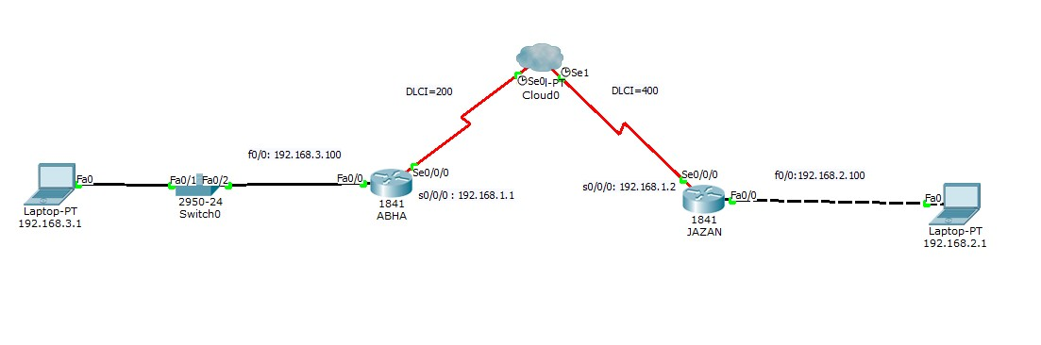

Configuration of Router Abha:-

Abha>enable Abha#configure terminal
Abha(conf) # int s0/0/0
Abha(conf-if) # ip add 192.168.1.1 255.255.255.0
Abha(conf-if) # encapsulation frame-relay ietf Abha(conf-if) # bandwidth 64
Abha(conf-if) # frame-relay map ip 192.168.1.2 200 broadcast Abha(conf-if) # frame-relay lmi-type ansi
Abha(conf-if) # no shut Abha(conf-if)# exit Abha(conf) # int f0/0
Abha(conf-if) # ip add 192.168.3.100 255.255.255.0
Abha(conf-if) # no shut
Abha(conf-if) # exit Abha(conf) # router rip
Abha(conf-router) # network 192.168.1.0
Abha(conf-router) #network 192.168.3.0
Abha(conf-router) # exit
Jazan>enable Jazan#configure terminal
Jazan(conf) # int s0/0/0
Jazan(conf-if) # ip add 192.168.1.2 255.255.255.0
Jazan(conf-if) # encapsulation frame-relay ietf
Jazan(conf-if) # bandwidth 64
Jazan(conf-if) # frame-relay map ip 192.168.1.1 400 broadcast
Jazan(conf-if) # frame-relay lmi-type ansi
Jazan(conf-if) # no shut
Jazan(conf-if)# exit
Jazan(conf) # int f0/0
Jazan(conf-if) # ip add 192.168.2.100 255.255.255.0
Jazan(conf-if) # no shut
Jazan(conf-if) # exit
Jazan(conf) # router rip
Jazan(conf-router) # network 192.168.1.0
Jazan(conf-router) #network 192.168.2.0
Jazan(conf-router) # exit
Verification :-

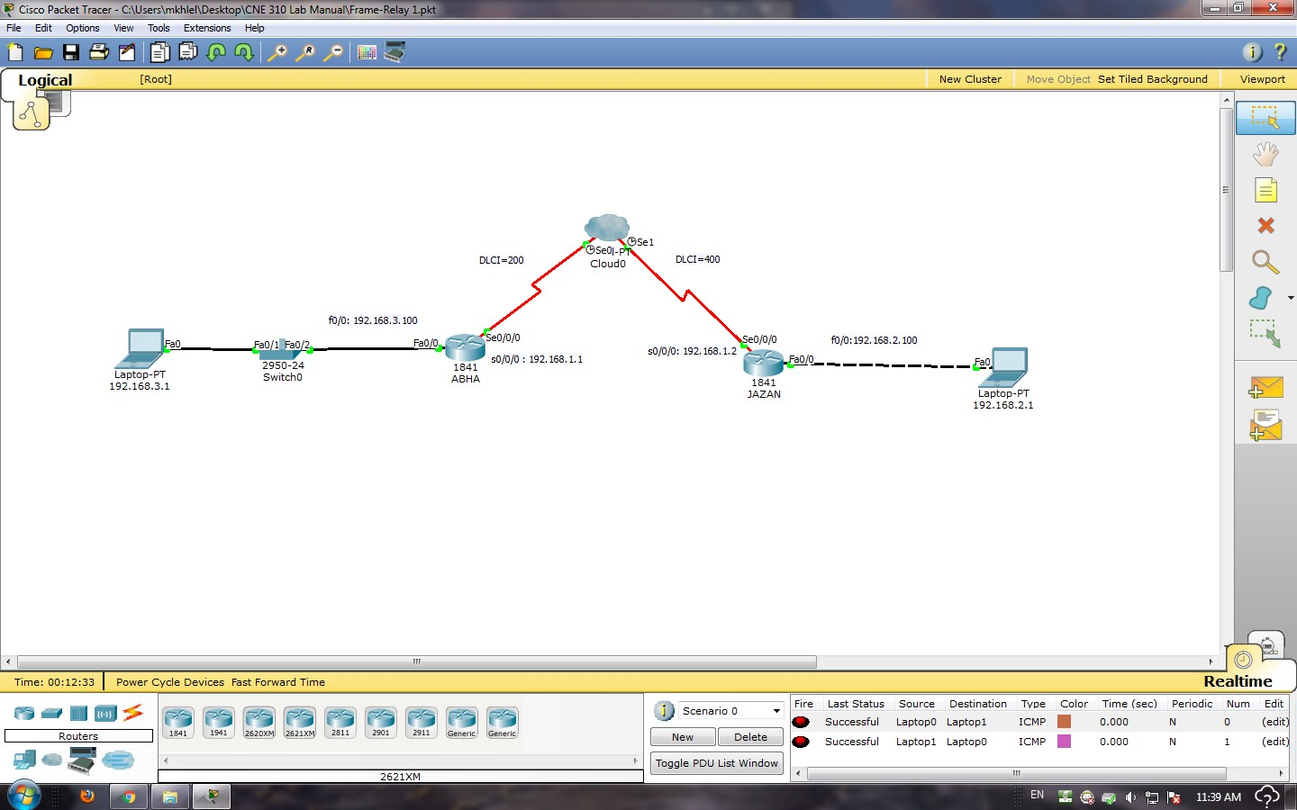

Output:

Result:

EXPERIMENT No. 12 Week No: 13 Week

FRAME-RELAY - Multipoint:

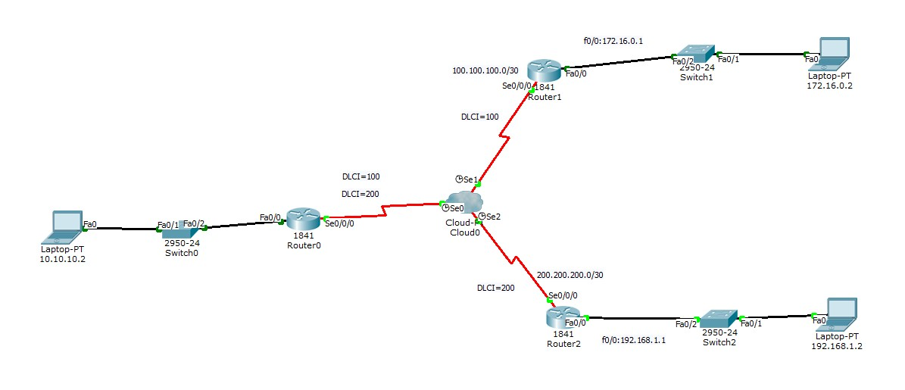

Configuration on Router R0:-

Router>enable

Router# configure terminal
Router(conf)# int f0/0
Router(conf-if)# ip add 10.10.10.1 255.255.255.0
Router(conf-if) # no shut
Router(conf-if) # exit
Router(conf) # int s0/0/0
Router(conf-if) # no shut
Router(conf-if) # encapsulation frame-relay ieft
Router(conf-if) # frame-relay lmi-type ansi
Router(conf-if) # exit
Router(conf) # int s0/0/0.100 point-to-point
Router(conf-if) # ip add 100.100.100.1 255.255.255.252
Router(conf-if) # frame-relay interface-dlci 100 Router(conf-if) # exit
Router(conf) # int s0/0/0.200 point-to-point
Router(conf-if) # ip add 200.200.200.1 255.255.255.252
Router(conf-if) # frame-relay interface-dlci 200 Router(conf-if) # exit
Router(conf) # router rip
Router(conf-router) # version 2

Router(conf-router) # network 10.0.0.0
Router(conf-router) # network 100.0.0.0
Router(conf-router) # network 200.200.200.0
Router(conf-router) # exit
Configuration on Router R1:-
Router>enable
Router# configure terminal
Router(conf)# int f0/0
Router(conf-if)# ip add 172.16.0.1 255.255.255.0
Router(conf-if) # no shut
Router(conf-if) # exit
Router(conf) # int s0/0/0
Router(conf-if) # no shut
Router(conf-if) # encapsulation frame-relay ieft
Router(conf-if) # frame-relay lmi-type ansi
Router(conf-if) # exit
Router(conf) # int s0/0/0.100 point-to-point
Router(conf-if) # ip add 100.100.100.2 255.255.255.252
Router(conf-if) # frame-relay interface-dlci 100
Router(conf-if) # exit
Router(conf) # router rip
Router(conf-router) # version 2
Router(conf-router) # network 100.0.0.0
Router(conf-router) # network 172.16.0.0
Router(conf-router) # exit

Configuration on Router R2:-
Router>enable
Router# configure terminal
Router(conf)# int f0/0
Router(conf-if)# ip add 192.168.1.1 255.255.255.0
Router(conf-if) # no shut
Router(conf-if) # exit
Router(conf) # int s0/0/0
Router(conf-if) # no shut
Router(conf-if) # encapsulation frame-relay ieft
Router(conf-if) # frame-relay lmi-type ansi
Router(conf-if) # exit
Router(conf) # int s0/0/0.200 point-to-point
Router(conf-if) # ip add 200.200.200.2 255.255.255.252
Router(conf-if) # frame-relay interface-dlci 200
Router(conf-if) # exit
Router(conf) # router rip
Router(conf-router) # version 2
Router(conf-router) # network 192.168.1.0
Router(conf-router) # network 200.200.200.0
Router(conf-router) # exit

Verification :-

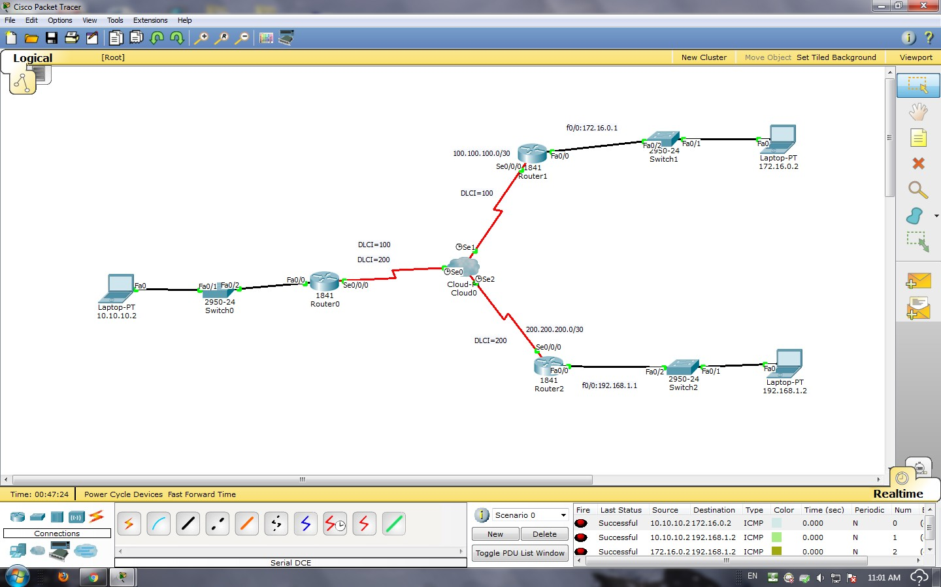

Result:

Output:

EXPERIMENT No. 13 Week No: 14 Week

Virtual Trunking Port Using Switches

Aim: - To configure VTP (virtual trunking port) server and clients in the switches and creates vlan’s to communicate in the network
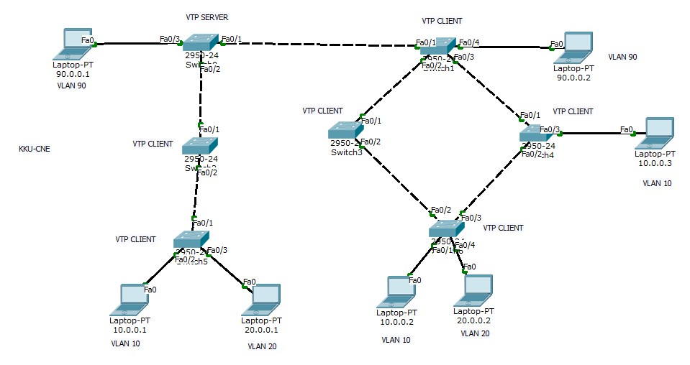

Configuration of switch-1 VTP Server:-

Switch(conf)#vtp mode server

Switch(conf)#vtp domain kku

Switch(conf)#exit
Switch(conf)# vlan 10
Switch(conf-vlan)name CNE
Switch(conf-vlan)# exit
Switch(conf)# vlan 20 Switch(conf-vlan)name CPE
Switch(conf-vlan)# exit Switch(conf)# vlan 90 Switch(conf-vlan)name CS
Switch(conf-vlan)# exit Switch(conf)#int f0/1
Switch(conf-if)#switchport mode trunk

Switch(conf-if)#switchport trunk allowed vlan 10,20,90
Switch(conf-if)#exit
Switch(conf)#int f0/2

Switch(conf-if)#switchport mode trunk

Switch(conf-if)#switchport trunk allowed vlan 10,20,90
Switch(conf-if)#exit
Switch(conf)#int f0/3

Switch(conf-if)#switchport mode access
Switch(conf-if)switchport access vlan 90
Switch(conf-if)exit
Configuration of switch-2 VTP Client:- Switch(conf)#vtp mode client
Switch(conf)#vtp domain kku
Switch(conf)#exit

Switch(conf)#int f0/1

Switch(conf-if)#switchport mode trunk

Switch(conf-if)#switchport trunk allowed vlan 10,20,90
Switch(conf-if)#exit
Switch(conf)#int f0/2

Switch(conf-if)#switchport mode trunk

Switch(conf-if)#switchport trunk allowed vlan 10,20,90
Switch(conf-if)#exit
Switch(conf)#int f0/3

Switch(conf-if)#switchport mode trunk

Switch(conf-if)#switchport trunk allowed vlan 10,20,90
Switch(conf-if)#exit
Switch(conf)#int f0/4

Switch(conf-if)#switchport mode access
Switch(conf-if)switchport access vlan 90
Switch(conf-if)exit
Note: Configure the remaining switches VTP clients respectively and communicate with same vlan’s.

OUTPUT:-

Result:

